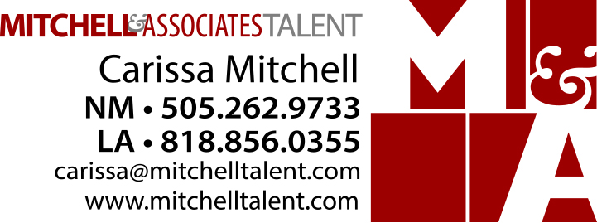

John Q. Actor
Union Status
Height: 6 ft. 6 in. Weight: 350 lbs.
Hair: Brown Eyes: Hazel

Film
Name of Project Role/ (Role Status) Production Co. / Director

New Media
Name of Project Role/ (Role Status) Production Co. / Director

Television
Name of Project Role/ (Role Status) Production Co. / Director

Commercial / Modeling
Name of Project Role/ (Role Status) Production Co. / Director

Theater
Name of Play / Musical Role/ (Role Status) Production Co. / Director

Print & Industrial
Name of Project Role/ (Role Status) Production Co. / Director

(List if you have space or put “Upon Request” - only use “Upon Request” if you have no space left to list it.)

Training
Name of Workshop Instructor Location of Training

Special Skills
List talents such as languages, accents, sports, leisure, ( Horseback riding, etc.), sp

